Spinach Tortellini Soup

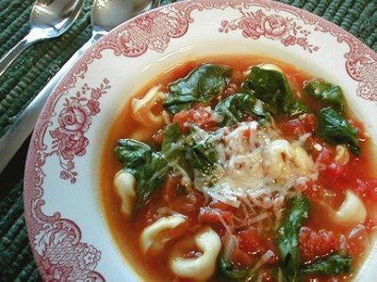
Ingredients
1 tbsp olive oil
1 onion, chopped
1 large carrot, diced
2 garlic cloves, minced
1/2 tsp dried oregano
1/4 tsp (salt
1/4 tsp pepper
4 cups vegetable or chicken stock
1cup pasta sauce (homemade or from a jar)
2½ cups fresh or frozen cheese or meat tortellini (or raviolini)
2 ½ cups baby spinach (I use the already cleaned bag available at Extra foods and Super Store) or cut broccoli is fine too
1/4 cup grated Parmesan Cheese (optional)

Preparation
- In a medium saucepan, heat oil over medium heat; fry onion, carrot, garlic, oregano, salt and pepper, stirring occasionally, until onion is softened, about 5 minutes.
- Add stock and pasta sauce; bring to boil. Reduce heat, partially cover and simmer for 10 minutes.
- Add tortellini and cook until pasta is almost tender about 7-8 minutes if frozen and 5-6 minutes if fresh.
- Add spinach or broccoli and return to simmer; cook until piping hot, about 1-2 minutes. Ladle into bowls; sprinkle with cheese.
Slow Cooker Italian Beef Stew

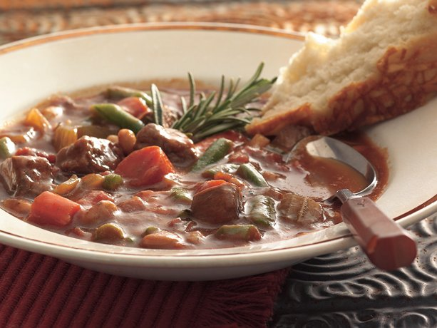

1 ½ pounds cubed beef stew meat
1 beef bullion cube
3 large carrots, cut into 1-inch pieces (2 cups)
2 medium stalks celery, cut into 1-inch pieces (1 1/2 cups)
2 cloves garlic, finely chopped
1 medium onion, coarsely chopped (1 1/2 cups)
¼ teaspoon pepper
1 can (19 ounces) kidney beans, rinsed and drained (optional)
1 can (28 ounces) crushed tomatoes, undrained
½ cup water
1 teaspoons Italian seasoning
2 cups frozen cut green beans or other mixed frozen vegetables.

- Place beef, beef bullion cube, carrots, celery, garlic, onion, pepper, kidney beans, tomatoes and water in order listed in 4-quart slow cooker.
- Cover and cook on low heat setting 8-9 hours (or 5-6 hours on high).
- The last 20 minutes of cooking stir in Italian seasoning, and frozen green beans (or other vegetables). Increase heat setting to high. Cover and cook 20 minutes or until green beans are tender.
Makes 4-6 servings

TIP: Serve a tossed green salad and fresh bread to round out this meal.

EASY BEEF VEGETABLE SOUP

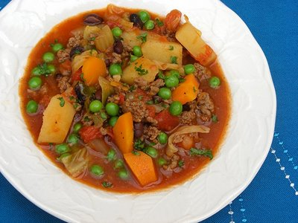
Serves 4-6 (Depending on appetite)
Ingredients
2 tbsp. oil
1 pound extra lean ground beef
8 cups water
1 (14 ounce) can diced (or crushed) tomatoes, undrained
1 onion, chopped
4 potatoes, peeled and cubed (optional)
1 (16 ounce) package frozen mixed vegetables
2 msg free beef bouillon cubes, crumbled
1teaspoon salt
½ teaspoon ground black pepper

Directions
- In a large pot over medium heat, add oil and cook beef until brown; drain.
- In the same large pot over medium heat, combine cooked beef, water, tomatoes, onion, potatoes, mixed vegetables, bouillon and salt & pepper. Bring to a boil, then reduce heat and simmer (partially covered) for 45 minutes.

Tip: for a heartier soup add ¾ cup rice or small noodles.

QUICK & SUPER EASY VEGETABLE SOUP

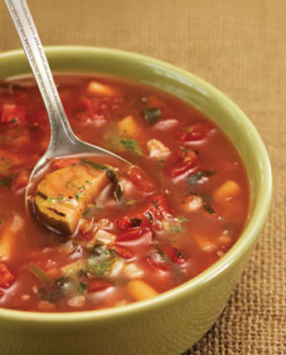

Ingredients
1 (14 ounce) can (or jar) tomato sauce
3 cups water
3 cups chicken broth
1 MSG free bouillon cube
3 cups frozen mixed vegetables
½ tsp. black pepper
1 tsp. Italian spices
6 ounces short dry pasta (small shells, tubetti or your favorite)

Directions
- Place the tomato sauce and water in a large pot over medium high heat.
- Bring just to a boil (medium high heat), add the mixed vegetables, bring to a boil again and then reduce heat to medium low.
- Let simmer (partially covered) for 30 minutes, add the pasta, if desired, cook for 15 minutes longer or until pasta is done.

TIP: if you don’t have chicken broth on hand, just add 6 cups of water and two bouillon cubes instead. Add more water of broth is needed.

ENJOY!

